Name _____________________________________________________________________________
-ot word family
Directions: Choose a pot. Color it appropriately. Write the word for the picture that is on the flower pot.
All words will end with -ot.
- 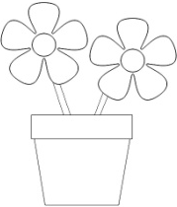 __________________________ 4. _________________________

- __________________________ 5. _________________________

- __________________________ 6. _________________________
Choose 1 –ot word and write a sentence.
__________________________________________________________________________________

__________________________________________________________________________________

